Stack Overflow Clone

Introduction:

The role of the project is to realize a simplified clone of stack overflow that can do the following features:

• We will design and implement a simple version of StackOverflow.

• Our system will have only one type of user

(two types/roles if you also implement the bonus features)

• No actions should be possible if the user is not logged in. The user’s passwords should

be store in the database encrypted.

1. Feature 1

• Users shall be able to ask questions. Each question must have an author, title, text,

creation date & time, picture and one or more tags. If an appropriate tag does not exist,

the user must be able to create one.

• The list of questions shall be displayed, sorted by creation date. The most recent

question should be displayed first.

• Questions may be edited or deleted by their author.

• The user must be able to filter questions by tag, via a text search, via users or for his

own questions. The text search should check the question title.

2. Feature 2

• Each question may be answered one or more times by any user (including the original

author).

• Each answer must have an author, text, picture and creation date & time.

• Answers may be edited or deleted by their author.

• When displaying a question individually, the list of answers must also be displayed

3. Feature 3

* Users may vote questions and answers (upvote and downvote, like and dislike).
* Each user may only vote once on each question or answer. Users cannot vote on their own answers or questions (Like&Dislike).
* On each voted question or answer, the vote count must be displayed (vote count = upvote/like count - downvote/dislike count). The vote count can be negative.
* The answers for a question must be sorted by their vote count. Answers with the highest
* vote count must be displayed first.

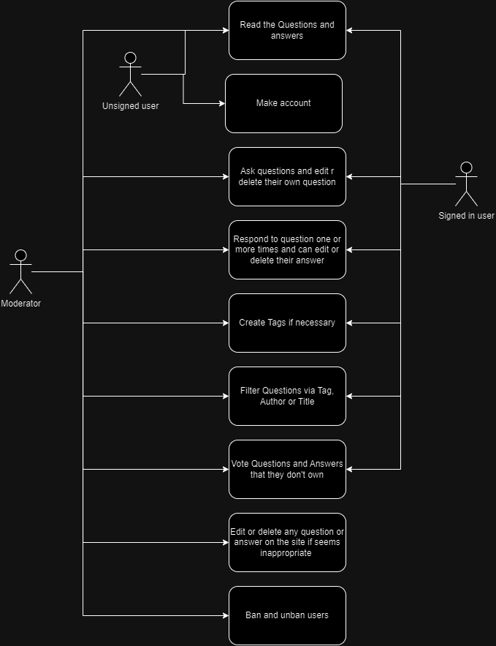Use Case Diagram:

Technical requirements:

* Java JDK: Version 21 or newer.
* Maven: For dependency management and project build.
* Spring Boot: Version 3.2.3.
* Database: PostgreSQL.
* IDE: IntelliJ IDEA, Eclipse, or any preferred Java IDE.

Project’s structure:

N-Layer architecture

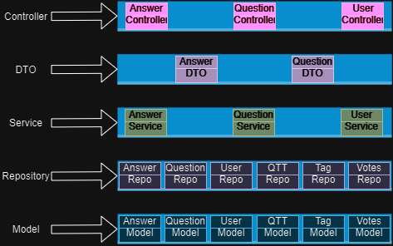

Class Diagram: 